hemal
Purna
dept. name:School of computing and data science
Sai University
Chennai, India
email address
E-Learning Platform

ABSTRACT
This project presents the design and implementation of a City Transport System using graph data structures in the C programming language. The system models transport networks where stations are represented as vertices and connections between stations are represented as edges.
To efficiently manage these connections, the project uses an adjacency list representation, which is memory-efficient and suitable for handling large and sparse networks.
The system supports essential CRUD operations (Create, Read, Update, Delete), allowing users to dynamically add, delete, update, and search for connections between stations. Dynamic memory allocation is used to ensure flexibility and efficient memory usage.
This project demonstrates how graph theory concepts can be applied to solve real-world problems such as transport route management. It also serves as a foundational model for advanced systems like route optimization, navigation systems, and smart city transport solutions
Keywords— Binary Search Tree, Course Management System, Data Structures, C Programming, E-learning Platform.
I. INTRODUCTION
Transportation systems in modern cities require efficient management to handle complex networks of routes and stations. Traditional methods of managing such systems can be inefficient when the network grows larger.
This project introduces a graph-based approach to model and manage transport systems. By representing stations as nodes and routes as edges, the system becomes structured and easy to manipulate.
The use of adjacency lists ensures that the system remains memory-efficient while supporting dynamic operations. This approach is widely used in real-world applications such as GPS navigation, metro systems, and network routing.
ΙΙ. ΟBJECTIVES
The main objectives of this project are:
To implement a transport system using graph data structures
To represent stations and connections using an adjacency list
To perform CRUD operations efficiently:
Add new connections
Delete existing connections
Update routes
Search for connections
To utilize dynamic memory allocation for flexible storage To design a menu-driven system for user interaction
III.SCOPE OF PROJECT
This project focuses on modeling a simplified transport network. It allows users to manage connections between stations efficiently.
Although the system is basic, it provides a strong foundation for:

IV. LITERATURE REVIEW

Graphs are widely used in computer science for representing relationships between entities. They are commonly applied in:

Transportation systems

Social networks

Communication networks

Among different graph representations, adjacency lists are preferred for sparse graphs due to their efficient memory usage.

Previous studies and implementations show that graph-based systems significantly improve performance in managing complex networks, making them suitable for transport applications.

V. METHODOLOGY

The system is developed using the following steps:

Define the graph structure using nodes and adjacency lists

Initialize the graph with a given number of stations

Implement core functions:

Add connection

Delete connection

Update connection

Search connection

Use dynamic memory allocation for storing nodes

Provide a menu-driven interface for user interaction

VI. TECHNOLOGY USED
- Programming Language: C
- Data Structure: Graph
- Compiler: GCC
- Platform: (Windows/Linux/Mac)
- Interface: Console faced
- Input method: Standard Input(scanf)
- Output method: Console Output(printf)

VII. ARCHITECTURE/SYSTEM DESIGN
The system follows a graph-based architecture:
- Each station = vertex (node)
- Each connection = edge
- Connections are stored using linked lists
This structure allows:
- Fast insertion of connections
- Efficient memory usage
- Easy traversal of neighboring stations
VIII. IMPLEMENTATION DETAILS
The implementation uses:
- Structures (struct Node) to represent graph nodes
- Pointers to link nodes dynamically
- Functions to perform operations:
  - addEdge() → Adds connection
  - deleteEdge() → Removes connection
  - updateEdge() → Modifies connection
  - search() → Checks connection
  - display() → Shows graph
Dynamic memory allocation (malloc) is used to create nodes at runtime.
IX. RESULTS / OUTPUT
Sample output:
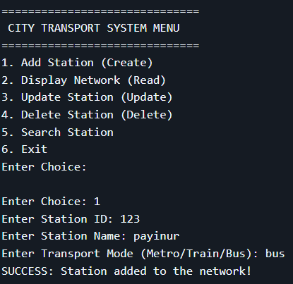
The system successfully performs all operations through a menu-driven interface.
Sample output demonstrates:
- Adding stations and connections
- Displaying adjacency list
- Searching and updating connections
The output confirms that the system behaves correctly and efficiently.

X. CONCLUSION
This project successfully demonstrates the implementation of a graph-based transport system using adjacency lists.
It provides:
- Efficient memory usage
- Flexible data handling
- Real-world applicability
The project serves as a strong foundation for advanced applications like route optimization, shortest path algorithms, and smart transport systems.

XI. FUTURE WORK
Future enhancements may include:
- Graphical User Interface (GUI)
- Database integration
- Add station name
- Shortest path algorithms
- Web-based e-learning platform
- User authentication system
- Graphical User Interface (GUI)
- Weighted graphs (distance, cost)
- Shortest path algorithms (Dijkstra)
- Web-based transport system
- User authentication system
- Real-time data integration

XII. REFERENCES
[1] GeeksforGeeks, “Binary Search Tree Data Structure,” GeeksforGeeks, 2024. Available:https://www.geeksforgeeks.org/dsa/binary-search-tree-data-structure/
[2] [2] Programiz, “Binary Search Tree (BST),” 2023.
Available: https://www.programiz.com/dsa/binary-search-tree
[3] Baeldung, “Binary Search Trees Guide,” Baeldung, 2022. Available: https://www.baeldung.com/cs/binary-search-trees

